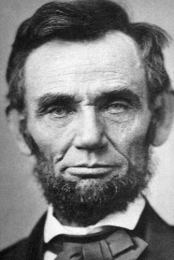
Lincoln’s Suicide Soliloquy

Abraham Lincoln was born into poverty and largely through self-education became a lawyer, a statesman, and the 16th president of the United States. He also suffered from severe depression throughout his life and during the most difficult times had strong suicidal urges. He would occasionally write poetry and it is believed that he wrote the following poem about suicide as he struggled through a period of deep depression.

Here where the lonely hooting owl
Sends forth his midnight moans,
Fierce wolves shall o’er my carcass growl
Or buzzards pick my bones.
No fellow-man shall learn my fate,
Or where my ashes lie;
Unless by beasts drawn round their bait,
Or by the ravens’ cry.
Yes! I’ve resolved the deed to do,
And this the place to do it:
This heart I’ll rush a dagger through,
Though I in hell should rue it!
Hell! What is hell to one like me
Who pleasures never knew;
By friends consigned to misery
By hope deserted too?
To ease me of this power to think,
That through my bosom raves,
I’ll headlong leap from hell’s high brink,
And wallow in its waves.
Though devils yell, and burning chains
May waken long regret;
Their frightful screams, and piercing pains,
Will help me to forget.
Yes! I’m prepared, through endless night,
To take that fiery berth!
Think not with tales of hell to fright
Me, who am damn’d on earth!
Sweet steel! come forth from out your sheath,
And glist’ning, speak your powers;
Rip up the organs of my breath,
And draw my blood in showers!
I strike! It quivers in that heart
Which drives me to this end;
I draw and kiss the bloody dart,
My last—my only friend!

